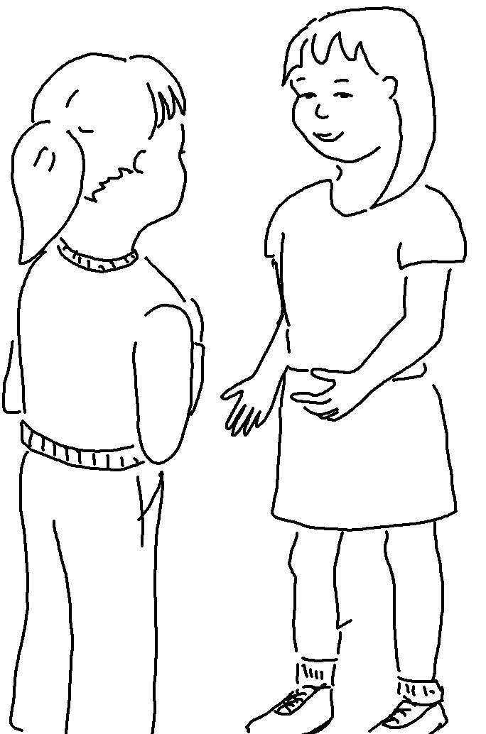
I was hungry, and you fed me.
I was thirsty, and you gave me a drink."
Matthew 25:35_{NLT}

